Java API

Author: $Author

Publisher: $Publisher

Date: $date

This sample template will demonstrate calling Java API within template. In normal case, template can access Java API from a reference variable. Most cases of reference variables are java.lang.String.

This sample gives a practical demonstration of macro and accessing the Java API of String.

Code learning:

Declaring macro
\#macro (macroname \$param[0..n])
\#end

Call Java API to convert String into Character array.
\$string.toCharArray()

Call Java API to return new String that is substring of this String
\$string.substring(beginIndex, endIndex)

Retrieve Collection of hyperlink under this element
\$element.hyperlinks

Line Concatenating
This sample requires Use Case with name containing multiple lines. See figure for example:



The above Use Case contains name with three lines

#macro (concatLine $str)#foreach ($c in $str.toCharArray())#if($c.getType($c)==15)#else$c#end#end#end

Original Results
#foreach ($usecase in $UseCase)
Name: $usecase.name
#end

Macro Results
#foreach ($usecase in $UseCase)
Name: #concatLine($usecase.name)
#end

Remove Square Bracket from Collection
When information is contained in Collection or Array, report automatically inserts and appends square brackets [] before and after data set.

For example:
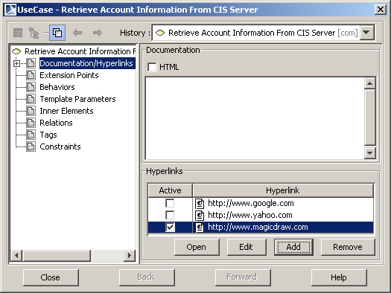

Use Case “Retrieve Account Information From CIS Server” contains hyperlink “http://www.google.com”, “http://www.yahoo.com” and “http://www.nomagic.com”. Printing data from the attribute hyperlinks of Use Case will return Collection of Hyperlink. The output will be shown as below:

[http://www.google.com, http://www.yahoo.com, http://www.nomagic.com]

You can eliminate square bracket by cutting the first and last character from text output. Using Java API substring function is one of solution to remove the first and last character

Original Results
#foreach ($usecase in $UseCase)
$usecase.name
Hyperlinks
$usecase.hyperlinks
#end

New Results
#foreach ($usecase in $UseCase)
$usecase.name
Hyperlinks
#set($text = $usecase.hyperlinks)
#set($endIndex = $text.toString().length() - 1)
$text.toString().substring(1, $endIndex)
#end

